Traffic Light Model

By Daniel Liang

Teacher: Mr. Bonafede

Course Code: TEJ 3O0

Due Date: Friday, January 22, 2016

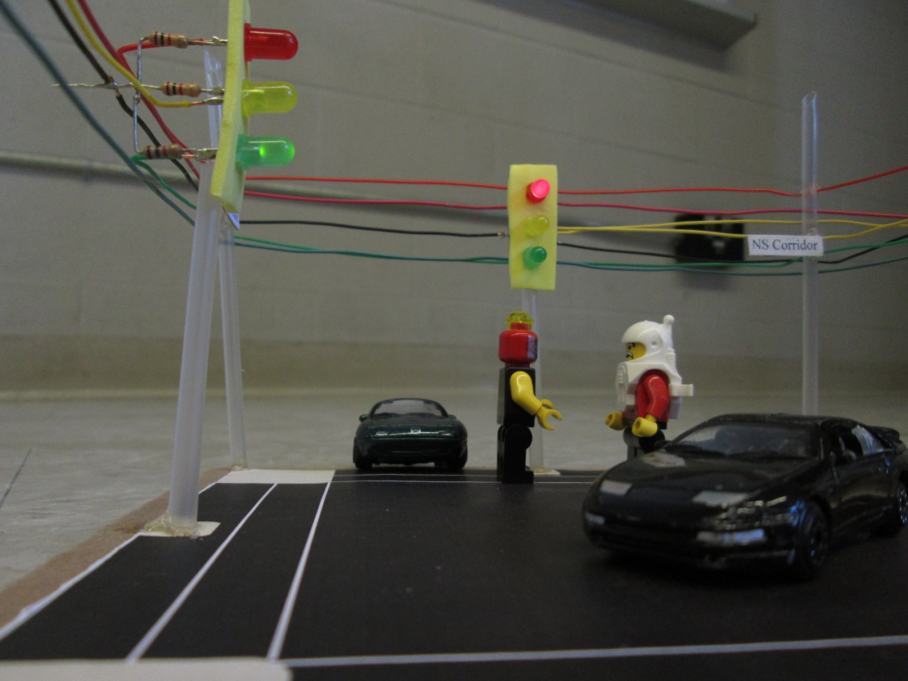

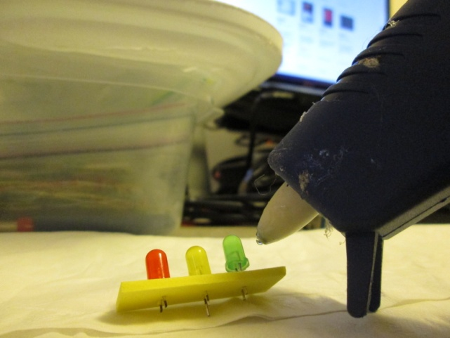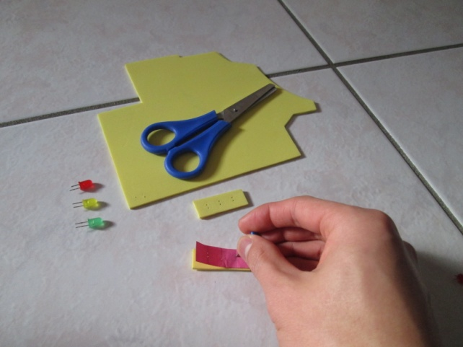Stages of Building

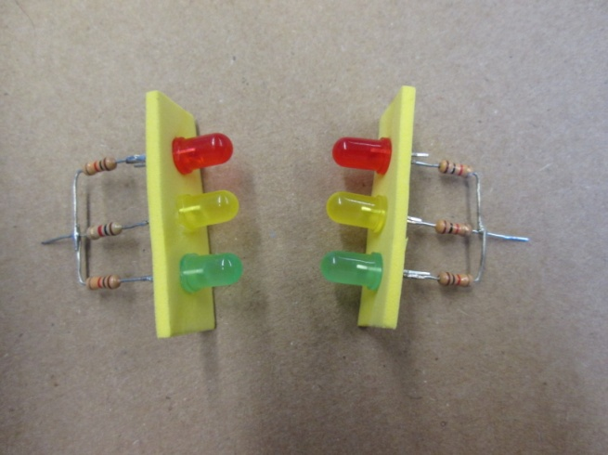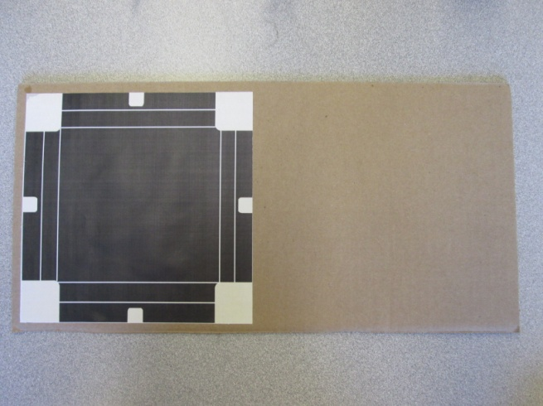

3. The base of the traffic intersection was glued onto the cardboard base using a glue stick.

4. A resistor was soldered to the negative lead of each LED. The resistors were soldered together.

2. The LEDs were glued in place with a glue gun.

1. The foam was cut into small rectangles and holes were poked in them for the LEDs using a paper template.

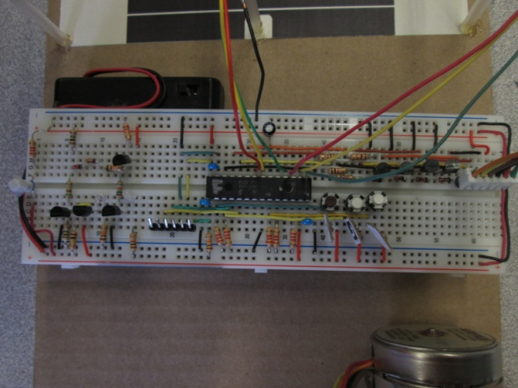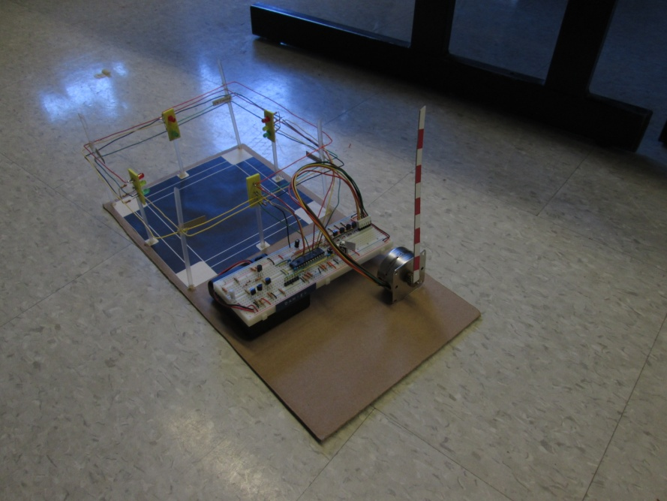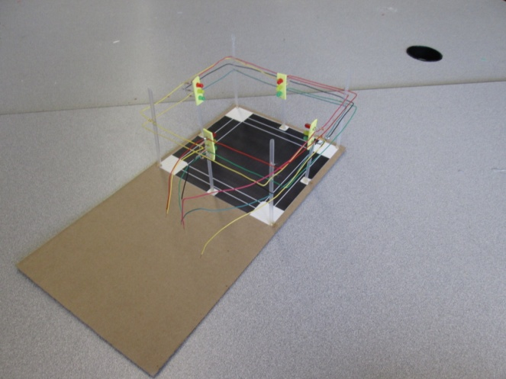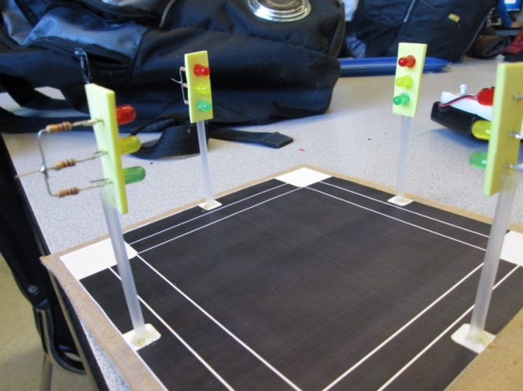Stages of Building

7. The circuit on the breadboard was constructed with the PIC, three buttons for input signals and four transistors for controlling the stepper motor.

8. The stepper motor was added and a boom gate made from cardboard was glued to the stepper motor.

6. Wires connecting the opposing traffic light positive leads were soldered and the wires were glued to drinking straws as support.

5. The traffic lights were glued onto drinking straws using hot glue and glued to the intersection base.